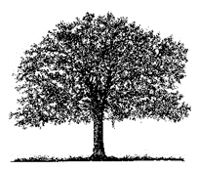
OAKVILLE YOUTH MEMORIAL SCHOLARSHIP

Norman and Pat Coon and their family started the Oakville Youth Memorial Scholarship Fund in June 1986 as a memorial to their daughter, Charlene Coon Gilmour.
Awarded annually for scholastic achievement, potential, or financial need, the scholarship is given to selected students who reside within the Oakville Parks and Recreation District or are active in the Oakville Presbyterian Church.
From the scholarship’s inaugural recipient Mike Cunningham in 1987, who went on to become a high school teacher in the area, the fund has benefited many students as they seek to continue their higher education.

The Oakville Youth Memorial Scholarship Fund is offering scholarships
for the 2023-2024 academic year. To qualify, applicants must:
- Live within the Oakville Park and Recreation District Boundaries (see description of boundaries on the following page) or be active in the Oakville Presbyterian Church.
- Be a high school graduate by June 2023 or be a current college/university student that is 25 years of age or less.
- Send the completed application packet to the Scholarship Committee via Oakville Presbyterian Church. The application must be postmarked by July 18, 2023 and only completed applications will be considered.

Scholarships are based on achievement, potential, financial need, and/or a combination of these.

DEADLINE FOR APPLICATION IS JULY 18, 2023
- Students applying for the scholarship may be contacted for a personal interview after the deadline date.
- All applicants will be notified of the decision of the Scholarship Committee by the second week of August, 2023.
- If a student selected to receive this scholarship is unable to attend school during the 2023-2024 year, alternate school terms may be considered.
Oakville Park and Recreation District Boundaries
NW Corner: Muddy Creek just NW of Lamb Dr.
North Border: Addresses on Tangent Dr. from Peoria Rd at the west and to the railroad tracks to the East.
East Border: The Railroad tracks running from Tangent Dr. at the north to just north of Brattain Dr.
South Border: Railroad tracks just north of Brattain then due west to the Willamette River.
(Does not include Brattain Dr. addresses)
West Border: Willamette River
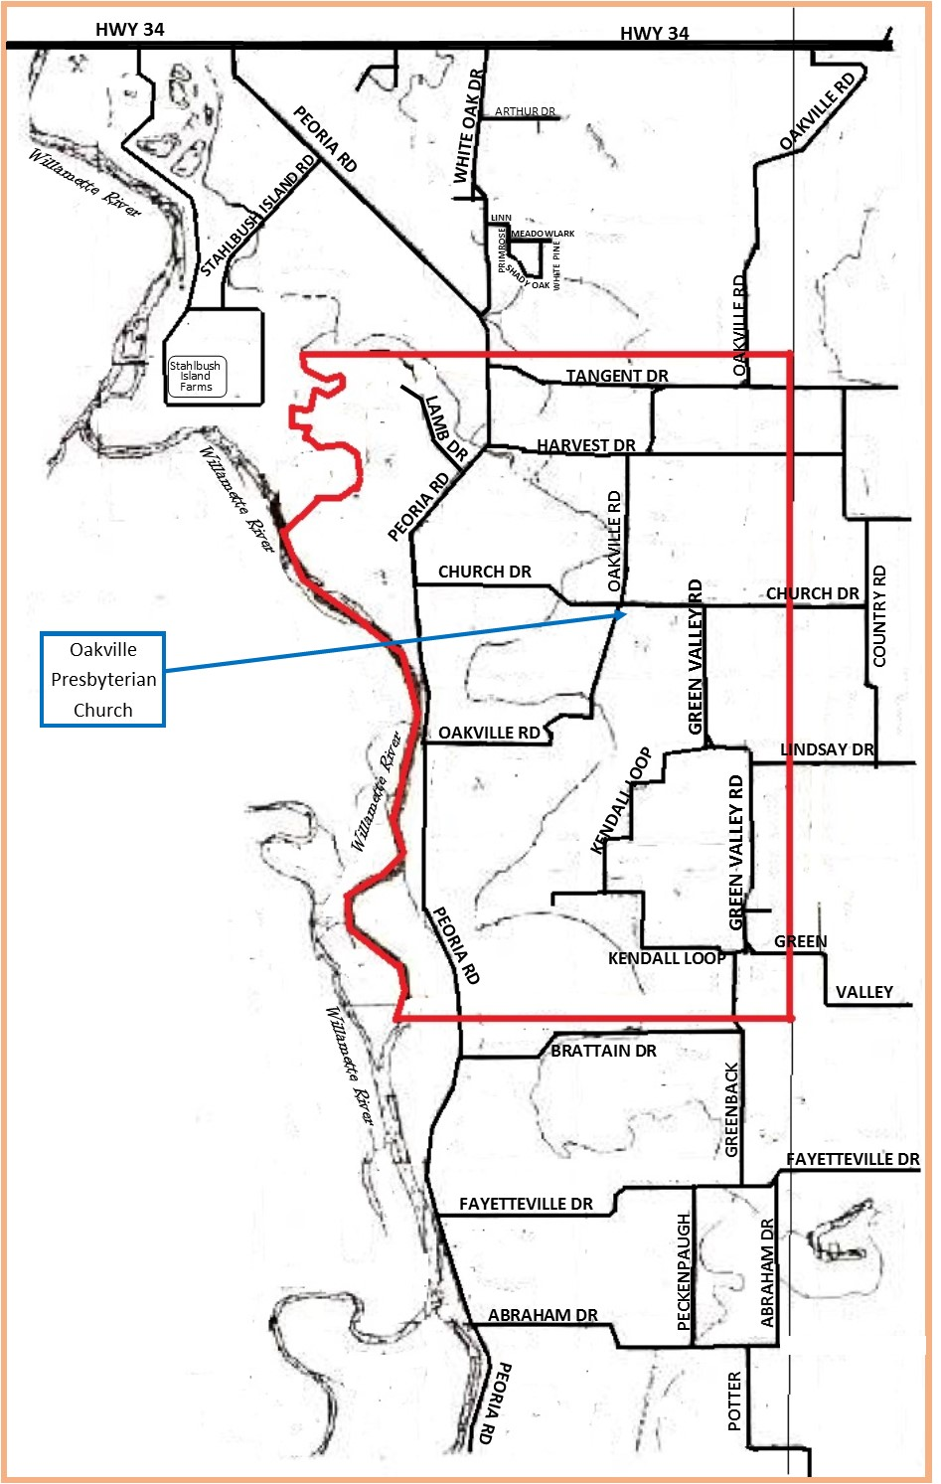

THE OAKVILLE YOUTH MEMORIAL SCHOLARSHIP

The completed application packet that you will send or deliver to the church is to include all the following items:

1. Personal Information Form [Complete page 4 of this packet]

2. Personal letter using the following headings: EDUCATION, WORK EXPERIENCES,
and FINANCIAL NEED. [See page 5 of this packet]

3. List of three references (personal, scholastic, and employer).
[Complete page 6 of this packet]

In addition, the following items need to be sent or delivered to the church:

1. Transcript of all your grades from high school and/or college.
Have your high school or college mail your transcripts to the church
(or email them if they can).

2. Completed reference forms from the people listed as your three references.
Options for completion and delivery:
- Print up the three copies in this packet and give it to your references (with a stamped envelope addressed to the church) and they can mail it in.
- Email the Reference Forms in this packet to your three references and they can complete them and email them directly to the church.
- Provide them a printed form which they and complete, scan and email it to the church.

DEADLINE FOR APPLICATION IS JULY 18, 2022

Email your completed scholarship packet to email@oakvillechurch.org by July 18, 2023 or send or deliver a printed copy to:
Oakville Presbyterian Church
29970 Church Dr.
Shedd, OR 97377
Must be postmarked no later than July 18, 2023.

Only completed applications will be considered. If any of the above five items are missing or is postmarked after July 18, 2023 the application will be automatically disqualified.
OAKVILLE YOUTH MEMORIAL SCHOLARSHIP APPLICATION
PERSONAL INFORMATION
Date____________________
Full Name________________________________________________________
(first) (middle) (last)
Phone Number___________________ Birth date___________________
(month/day/year)
Address_________________________________________________________
________________________________________________________
Email___________________________________________________________
High School Graduation Date_______________
High School Name & Location______________________________________________
______________________________________________
Current Year in College/University ______ Major_______________________________
College/University Name & Location_________________________________________
_________________________________________
Recognitions and Awards (indicate year and purpose of award): Use back of this page if necessary.
_______________________________________________________________________
_______________________________________________________________________
_______________________________________________________________________
_______________________________________________________________________
Parent(s) Name(s)_________________________________________________
Parent(s) Address_________________________________________________
_________________________________________________
Parent(s) Phone ___________________ Parent(s) Email _________________________
_______________________________________________________________________
OAKVILLE YOUTH MEMORIAL SCHOLARSHIP APPLICATION

PERSONAL LETTER
On a separate piece of paper tell us a little bit of your background, educational activities, work experiences (if applicable), your financial needs, and your future goals. Use the following headings (in bold caps) in your typed letter:

BACKGROUND
Share a bit about your background, your experience in the Oakville community and/or Oakville Church.

EDUCATION
Tell us about your previous education, your current education experience and your future educational goals.

WORK EXPERIENCE
If any, what previous work experience do you have, and any current employment? What are your short term and long-term career goals currently?

FINANCIAL NEED
What educational expenses (tuition, books, supplies, etc.) do you anticipate for this coming school year? What financial resources do you anticipate assisting you with your educational plans? (Personal income, Parents/family, grants, scholarships, loans, etc.). Estimated amounts are adequate.

TRANSCRIPTS

Be sure to have your high school or college transcripts sent to the church in plenty of time so that they arrive before July 18, 2023! Any arriving later will disqualify you for the scholarship!

OAKVILLE YOUTH MEMORIAL SCHOLARSHIP APPLICATION

THREE REFERENCES

List below the names of three (3) adults, unrelated to you, who you have asked to submit a reference form for you.

PERSONAL REFERENCE:

Name/Title:____________________________________________________

Address:_______________________________________________________
______________________________________________________________

Phone:____________________ Email: ______________________________

SCHOLASTIC REFERENCE:

Name/Title:____________________________________________________

Address:_______________________________________________________
______________________________________________________________

Phone:____________________ Email: ______________________________

EMPLOYER REFERENCE: (If not applicable, please have 2 personal references)

Name/Title:____________________________________________________

Address:_______________________________________________________
______________________________________________________________

Phone:____________________ Email: ______________________________

Applicant’s Signature ____________________________Date___________________

OAKVILLE YOUTH MEMORIAL SCHOLARSHIP
REFERENCE FORM

Applicant’s Name:________________________________________________
has applied for the Oakville Youth Memorial Scholarship and has listed you as a reference. You may use the back of this page, or attach additional sheets if you need more space. Please type or print using black ink when completing this form.

1. How long have you known the applicant? In what capacity?

2. Do you believe the applicant will be successful in his/her educational career?
Why?

3. What is your evaluation of the applicant’s academic ability?

4. Are there economic or other unique factors that make the applicant worthy of
receiving scholarship support?

5. Additional comments:

Your name, title, and relationship to the applicant. Please print.

_______________________________________________________________________

Signature: _______________________________Daytime phone___________________

Please send this completed form before July 18, 2023

Send by email to: email@oakvillechurch.org or

By printed copy to Oakville Presbyterian Church29970 Church Dr. Shedd, OR 97377

OAKVILLE YOUTH MEMORIAL SCHOLARSHIP
REFERENCE FORM

Applicant’s Name:________________________________________________
has applied for the Oakville Youth Memorial Scholarship and has listed you as a reference. You may use the back of this page, or attach additional sheets if you need more space. Please type or print using black ink when completing this form.

1. How long have you known the applicant? In what capacity?

2. Do you believe the applicant will be successful in his/her educational career?
Why?

3. What is your evaluation of the applicant’s academic ability?

4. Are there economic or other unique factors that make the applicant worthy of
receiving scholarship support?

5. Additional comments:

Your name, title, and relationship to the applicant. Please print.

_______________________________________________________________________

Signature: _______________________________ Daytime phone__________________

Please send this completed form before July 18, 2023

Send by email to: email@oakvillechurch.org or

By printed copy to Oakville Presbyterian Church29970 Church Dr. Shedd, OR 97377

OAKVILLE YOUTH MEMORIAL SCHOLARSHIP
REFERENCE FORM

Applicant’s Name:________________________________________________
has applied for the Oakville Youth Memorial Scholarship and has listed you as a reference. You may use the back of this page, or attach additional sheets if you need more space. Please type or print using black ink when completing this form.

1. How long have you known the applicant? In what capacity?

2. Do you believe the applicant will be successful in his/her educational career?
Why?

3. What is your evaluation of the applicant’s academic ability?

4. Are there economic or other unique factors that make the applicant worthy of
receiving scholarship support?

5. Additional comments:

Your name, title, and relationship to the applicant. Please print.

_______________________________________________________________________

Signature: _______________________________Daytime phone___________________

Please send this completed form before July 18, 2023

Send by email to: email@oakvillechurch.org or

By printed copy to Oakville Presbyterian Church29970 Church Dr. Shedd, OR 97377

